

Prepared by:

**Gerber Technology**

**YuniquePLM**

**Quote Dashboard**

The Quote Dashboard is an area where each user can view all of the quotes filtered by specific agent(s). The quotes can be arranged in a list or calendar view. To access the Quote Dashboard, click on the **Quote View** in the left navigation.

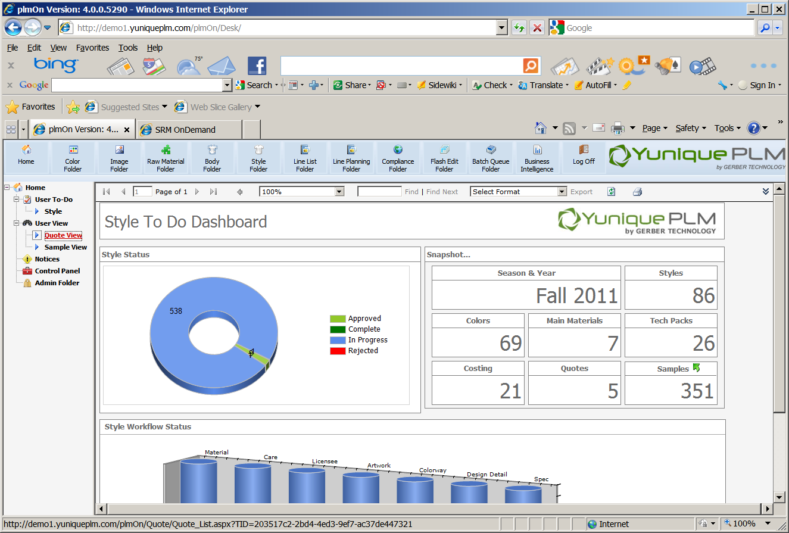

Once the quote folder is presented it will be blank except for the nodes on the left side of the explorer window. Each user will be able to customize the list presented in the quote folder by clicking on the Filer Quote node.

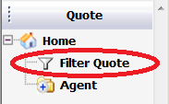

The list of available agents will be presented on the left. Agent named can be highlighted and then moved to the selected list on the right using the green control arrows in the center.

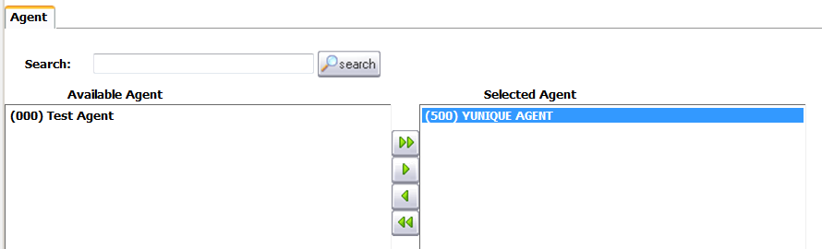

Clicking on the Save button across the top of the screen will store the new filter settings.



Once the agents have been selected from the list a node will be added on the left side of the explorer window for each agent.

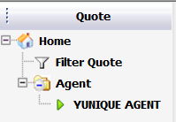

When a user clicks on a specific agent node a calendar view will be presented on the right side of the explorer window with information listed on the due date for each specific quote.

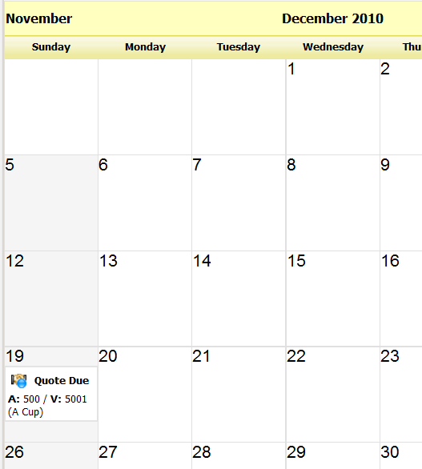

The calendar settings can be changed to a month, week or day view to suite the user needs.



The setting can also be changed to list view of all outstanding quotes by agent. To change to a list view, select the Quotes tab across the top of the window.

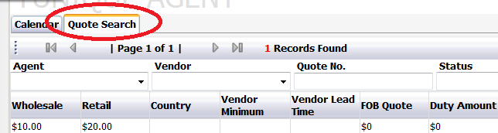

The additional fields across the top of the quote list can be used to filter the list by specific information related to quotes for the selected agent.

If changes need to be made within a specific quote the record can be opened by highlighting the quote from any view and double clicking. The quote record will be presented in full.

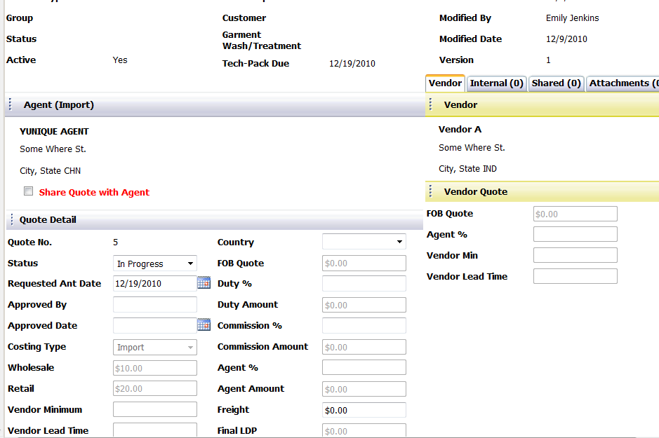

Changes can be made to individual fields within the quote, vendors can be replaced or the record can be deleted completely. For any changes made click on the Save button across the top of the window to store the record.



Each user can have multiple agents listed in the filter list or at any time change the list by repeating the steps at the Filter Quote node.